**SUPPLEMENTARY FIGURE S8: NET Monetary benefit analysis**

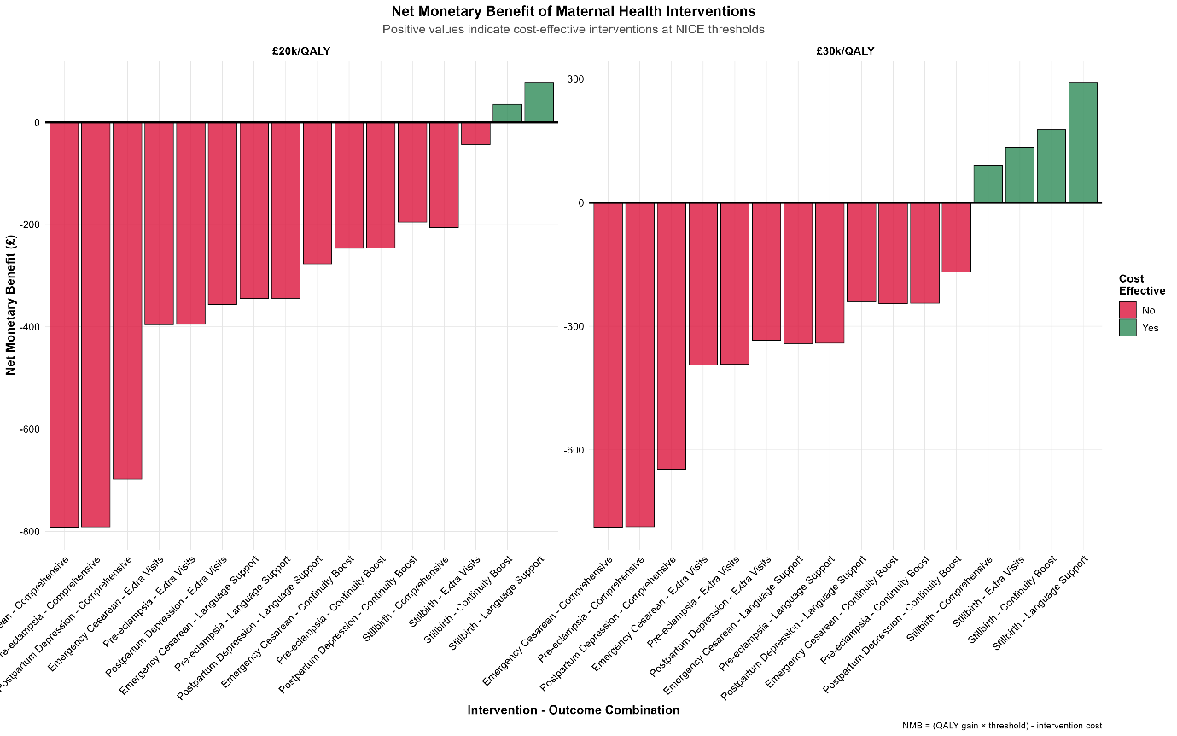

Net monetary benefit of maternal health interventions at £20k/QALY and £30k/QALY threshold. Positive values indicate cost-effective interventions. Most interventions show negative net benefit at £20k/QALY threshold but several become cost-effective at £30k/QALY. Language for postpartum depression consistently shows positive net monetary benefit. NMB = (QALY gain * threshold) - intervention